The Franciscan Church of St. Bonaventure
1300 Leslie STreet
Toronto, Ontario
M3C 2K9
416.447.5571 Fax: 416.447.4082

Our Mission

We are a community
of believing people,
who have chosen St. Bonaventure’s as our spiritual home
within the Roman Catholic Archdiocese of Toronto.

Together,
inspired by the Franciscan Spirit,
we seek to live and proclaim
the Gospel of Jesus Christ
in our daily lives
by becoming a holy people
and serving our sisters and brothers
for the Glory of God.

The Franciscan Church
of St. Bonaventure


Parish Registration Form

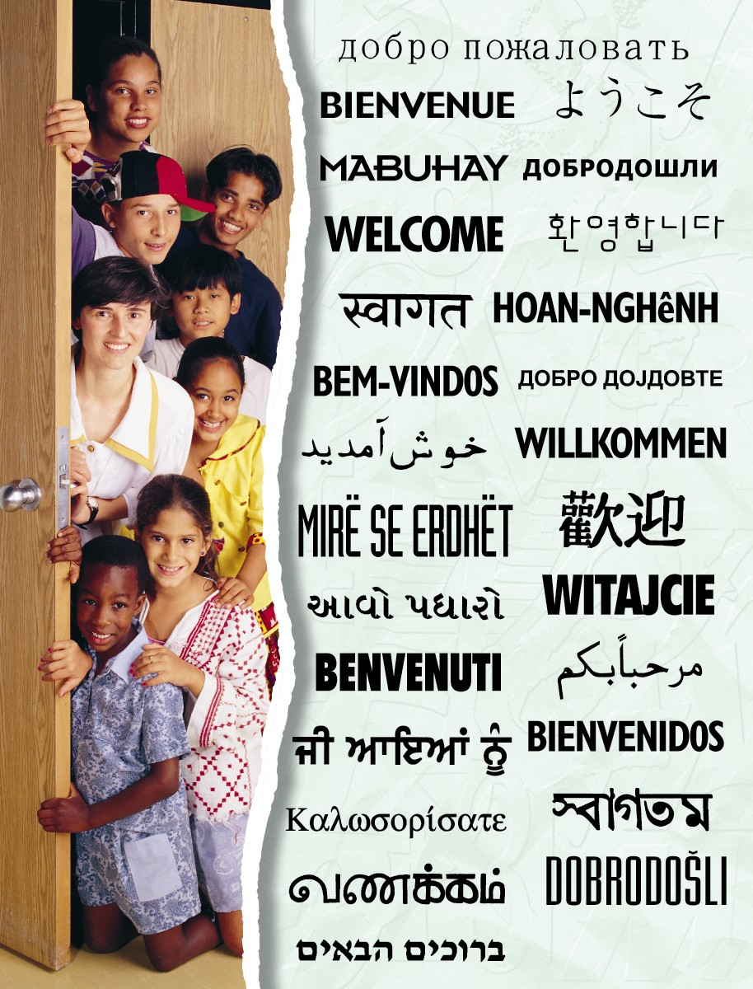
Welcome to St. Bonaventure

Welcome and thank you for taking the time to join the very special catholic community at St. Bonaventure. In the spirit of St. Francis of Assisi, the Franciscan Friars, Secular Franciscans and parishioners work together to respond to the spiritual hungers of the community. We hope that you will find a true spiritual home with us at St. Bonaventure.

We have a very active community at St. Bonaventure. A number of groups work together on activities that support our parishioners and people in the greater community. Our parishioners visit the homebound, volunteer at the local food bank, provide meals for the homeless and provide emergency support and counselling services to name just a few.

Complete the registration information below and return it to us for our files. This information will be stored in our confidential database accessible only to the Archdiocese of Toronto and the Franciscans. We encourage you to keep your records up-to-date by letting us know about changes such as a new address, births and marriages.

Register every member of your household (adults & children). Please Print!

Last Name | First Name | Birth date  Day/Month/Year | Sex | Status* | Religion | Email Address

*Status: child, married, single, religious, clergy, widowed, separated, divorced, common-law etc.

Address and Telephone
Street number: Street name:
Apartment/unit number:
City: | Postal Code:
Home Telephone: | Business Telephone:
Please select ☑ one option for your Sunday Offerings:
□ I would like to use Automatic Debit from my account. Enrolment forms are available at the Ministry Centre and on our website www.st-bonaventure.ca/aboutus.
□ I would like to use Church Envelopes for cash / cheques

Please return this form to the church by placing it in the collection basket on Sunday.
www.st-bonaventure.ca & www.franciscans.org

